
MATES Computer Science
Senior Capstone Project Bi-Weekly Progress Report - 4
Project Title | Project Egress
Team Members | Ethan Todd, Liam Bragg, Madeline Rosshirt
Dates Covered by Report | 05/04/26 to 05/08/26; 05/11/26 to 05/15/26
Link to Github | https://github.com/Fennec427/Project-Egress

Summary of Project
Our project is called “Project Egress”. It is a 2-D puzzle platformer made in Unity with pixel art for graphics. Inspired by the video games Splatoon and Portal, the gameplay is centered around the use of different paint colors and their abilities across multiple levels of scaling difficulty. There will also be a variety of tools used to spread the paint. Levels will have stage elements such as spike traps or moving platforms to add a uniqueness to each level.

Summary of Progress this Period
The level finish flag was started and completed in this sprint. With this, level 1 has been completely finished, and has been merged into the main branch. Merging level 1 into the main branch has also fixed breaking changes in the main branch (more on that later). Currently, the UI, such as the title screen, level select, and pause menus are being worked on, with some buttons having functionality. Pre-painted tiles have been made. These tiles act similar to the planned paints, where they apply an effect to the player. Two of these tiles have been made: the red and the orange tiles.

Detailed Progress this Period, separated by Team Member (with pictures)

Ethan: The first thing I did was adjust the animations for the “Teleporter” prefab since they were not cycling properly at the start of this sprint. This didn’t take too long and I managed to get it done in one school day. After that, we had to pause and take a small break to make some edits and adjustments to the previous progress report of ours. While this was going on, I made sure I stayed productive by editing previous sprites to match up in terms of color. Next, I tried to get a head start on some other future tasks until I realized I was thinking too far into our reach goals so I just stuck to planning out the entire structure/ theming the levels we would make after we were done with our mechanics since time was of the essence and I thought it would be a good idea for us to use/ have this plan in general (for communication purposes). Then, I spent a quick day editing and finishing “Level 1” of our game in terms of mechanics. After that, I moved on to writing the code, making the animations, and implementing the “Finish Flag” prefab to our game to add at the end of levels to have the player transition from one level to the next. This took a little longer than anticipated, but with the help of Liam, it became fully functional and even better than I had initially wanted it to be. Lastly, I did a tiny bit more work on sprites involving the title and such.
Ethan’s Photos:
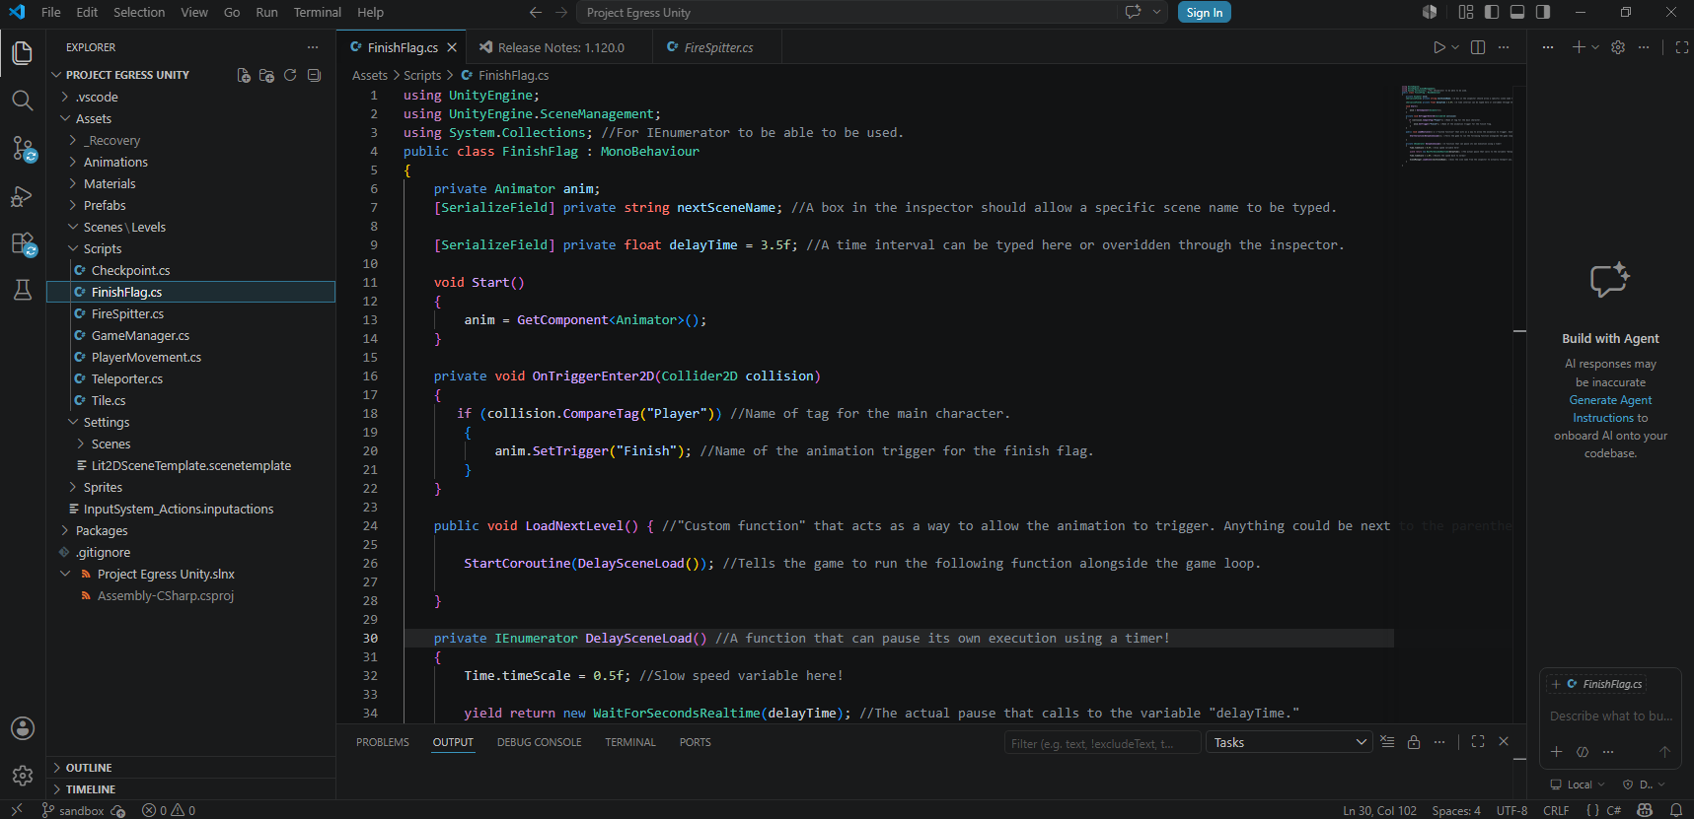
- Above is a screenshot of some of the code involving the “Finish Flag” I made with comments in there for the rest of my group.
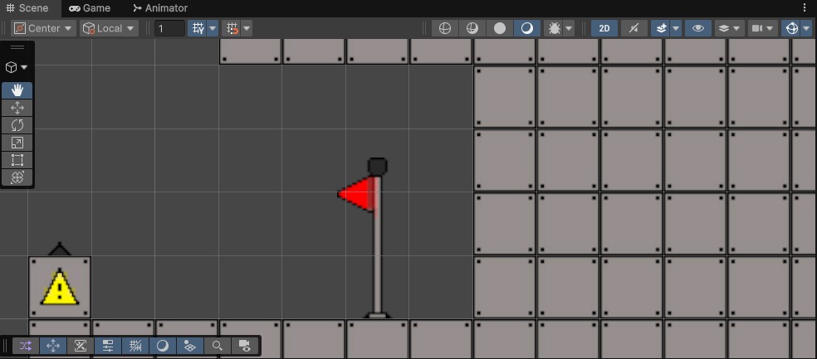
- Above is a screenshot from the Unity Editor showing what the “Finish Flag” prefab looks like at the end of “Level 1.”
Madeline: The First thing that I did was finish up the parts of paint switch that I needed to be worked on. Turns out that there was an error when I was making the sprite causing all of the wheels for the three paint wheel to look off so I fixed it. That caused me to have to re-crop the sprites (since there are a lot of areas with no pixels in the sprite sheet unity crops them wrong. While making the code I had a few errors causing it to not track the mouse properly so I added some debug code to help out that would print the current mouse position to the console. Eventually I got it fixed and since I forgot to remove the debug code I had to push a 2nd commit. I then had an adventure trying to figure out what to do with the green painted tile’s symbol to make it look sticky. This took a day or so to do and it was pretty important as we needed it to get painting for the sticky paint. It went through a lot of iterations (most of which weren’t saved as I kept saving over the same file and also it would require a bunch of extra files that aren’t needed) I asked around in the class for people who didn’t know what it was for and we got some people to say sticky (and considering that it will be most likely used in a line and it is after all of the other paints it would be obvious that it is something positive). After that I spent this week working on exclusively the new Menus-&-Other-UI branch. I started off by having to download a bunch of UI assets from Unity to even start working on them. However afterwards I was able to make the main menu and level select. The next day I worked on getting the buttons to work (minus the levels in level select as the First Level wasn’t finished yet at the time but it will be an easy thing to put in). I spent the next two days working on the pause menu. All you need to do is press escape to open it up and from there you can click on resume, press escape again (both of which unpause the game), or go back to the main menu. This only leaves the settings menu to be worked on (which is going to be the hardest one but it should be fine). Please do keep in mind that all of the menus are a WIP so they have no sprites or anything and are not representative of how they will look later.
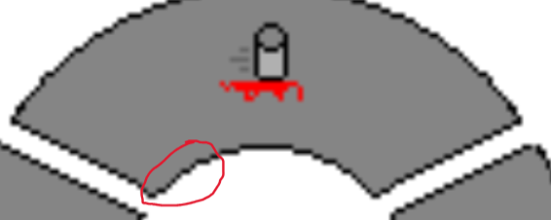
Above are the Two paint wheels side by side. There was this weird bump on the bottom left of the top part (was easier to see while testing the paint switch) but I fixed it (right)

The New Sticky block (meant to look kinda like when you put slime between two objects and it droops down)
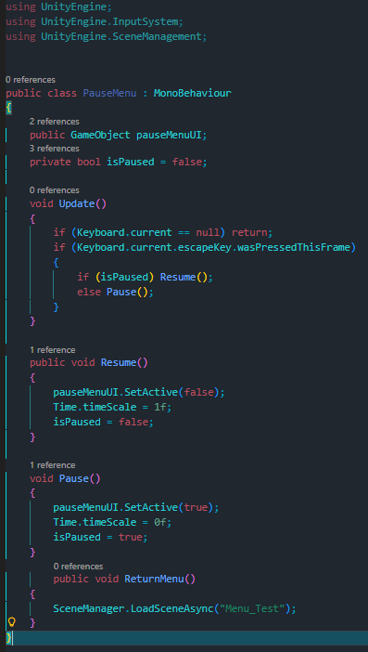
Above is the pause menu code since it looks really simple but was actually really hard to make… (also while exploring forums for various things I managed to catch the tip of checking if a keyboard is plugged in which is what the “== null” thing is at the top.)
senior-cs-capstone-progress-report-4a.mp4
Above is a video showcasing both the paint switch and the three different menus
Liam: I did not get a chance to start the paint shooting mechanic like I said in Report 3. Instead, I actually started working on the pre-painted tiles, which are special tiles that will apply the paints’ effects to the player. I completed 2 out of the 3 pre-painted tiles. To do this, I modified a normal tile, applying one of the pre-painted tile sprites, then changing the underlying code to support having both pre-painted tiles and normal tiles all at once to reduce the amount of scripts needed. The pre-painted tiles that are currently done are the red and orange tiles, which give speed or bounce the player respectively. I also helped Ethan with making the finish flag, giving him ideas on how to implement X or how to go about doing Y. When the finish flag was added in, I merged the branch that contained level 1, which is now complete, into the main branch, which fixed the breaking changes. As always, I did any and all merge commits to get the branches up to date, including merges ranging from simply fast-forwarding the commit HEAD to having multiple merge conflicts (with some that would need some extra fixes after the merge was complete). All (2) videos found in this progress report were made by me.
senior-cs-capstone-progress-report-4b.mp4
Above: A video showcasing the 2 completed tiles and their effects on the player

Difficulties Encountered this Progress Period

One issue Ethan personally had was a slight miscommunication/ misunderstanding on how a sprite(s) should have been done recently. It wasn’t detrimental or anything, it just was a minor hurdle that will be resolved extremely soon. Generally, we all had issues with slow virtual machines.
There were recently breaking changes in the main branch that slipped in from a merge commit that added the sandbox branch to main. The breaking changes included a level 1 that was missing bug fixes and prefab settings, likely due to level 1 being improperly imported from its respective branch into the sandbox (likely due to switching the branch while level 1 had unsaved changes, then saving it in a different branch).
These have been fixed when the latest merge changes from the Level 1 branch were added.
Yet again no GitHub repository in Maddie’s virtual machine! And her computer also now takes a minute to load each play test. (instructions to fix the branch references will be added to the Lessons Learned document soon)

Updated Trello Board and Discussion
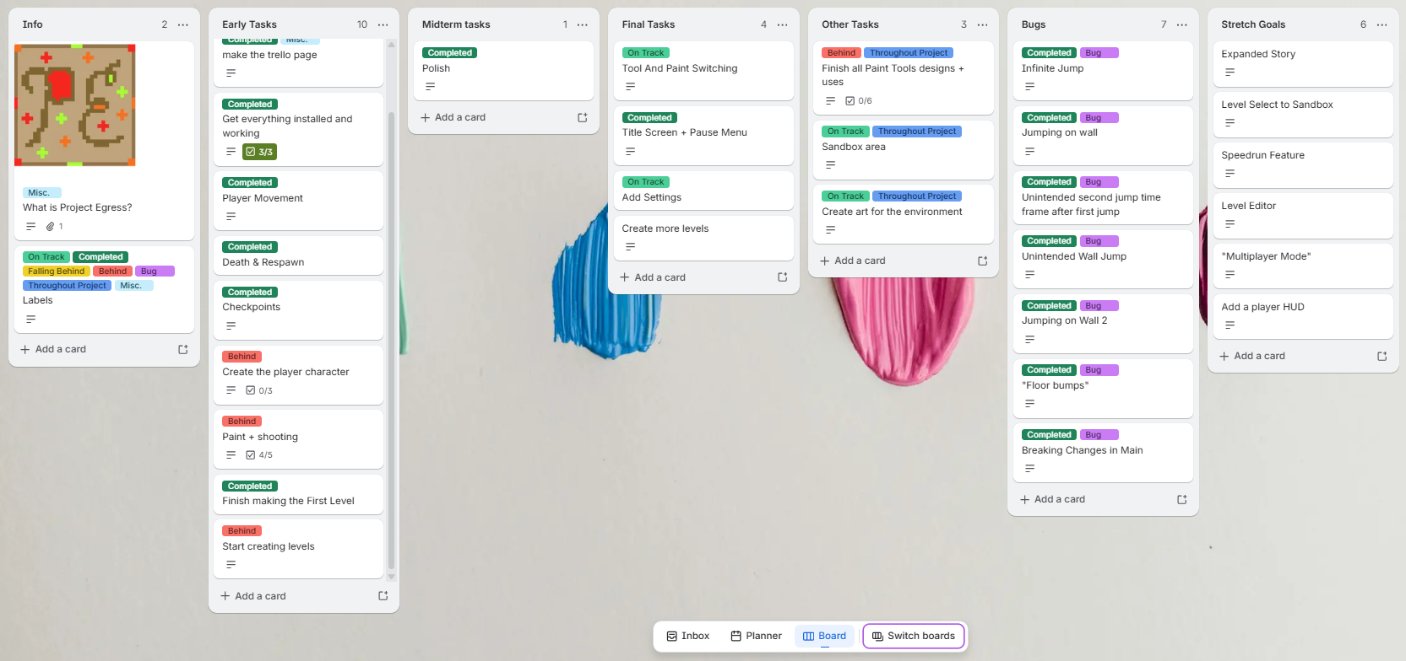
https://trello.com/b/D29yQgac/project-egress
Yet again not too many changes to the Trello board but more than last time I believe.
Checked off 4/5 of the items in the paint + shooting card. First Level tag changed to completed. Title Screen and pause menu changed to completed as those are done (minus the visuals which are simple to do). Settings changed to On Track as that is the next UI that will be worked on. Finish all paint tools designs + uses changed to behind (and it probably won’t be finished as tools are becoming less likely due to not even having 1 finished at this time).

Tasks to Be Worked on in Next Progress Period

Generally: The most important thing to be working on is the paint mechanics and tools. All of the paint besides green is done and there is no shooting yet. Other important things are: Settings, The UI fleshed out (actually making them presentable sprites and other misc. things), Spritework for at least what was supposed to be the temporary character holding their arm out (so it can be rotated for shooting, and making more levels.

Ethan: For me, I plan on working on some spritework, likely primarily on my own time, in order to finish up some of the incomplete or unfinished sprites in a lot of the last few facets of our project. After that, I plan on moving onto working on setting up the scenes for the rest of the levels, beside “Level 1” (which is already essentially done). By the time I have fully finished this, I will likely be able to focus on the levels themselves because the paint will be done. At this point, we should all be working on the levels as efficiently as possible (making tweaks and adding/ adjusting small mechanics as needed) in order to fully finish the project on time. My plan is very likely to stay, although I might have to shift focuses if something else important arises, so this is still slightly subject to change.

Madeline: I plan on mostly working on finishing the UI by making some new sprites for buttons and a title with some stuff to throw in the background to flesh it out a bit more. The Settings are another part of this as I need to make them entirely. Afterwards I plan to help as much as I can with level creation and some other spritework as the semester is coming to a close and we don’t even have anything showing off our main mechanic.

Liam: I will make a 3rd, green pre-painted tile, which will stick the player to the tile. After that, I will likely continue on that painting mechanic path that I set in progress report 3: shooting paint, applying paint to tiles, and paint effects (this one will probably be reduced in the amount of work needed, as some of the effects are already there; it just needs to hook into the tile paint). I can also help out my team with getting level 2 started up. And as per the usual, I will be handling any merges my team needs me to do.

Additional Information
n/a

